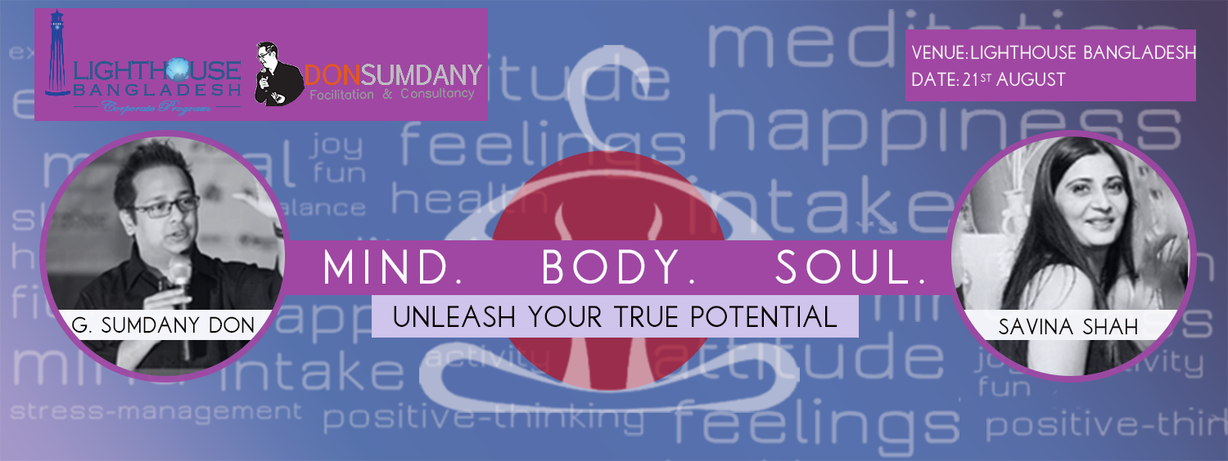

S

avina is a yoga, meditation, reiki healer, & theta healing master & practitioner. It gives her great joy to be able to utilize this platform to share with you all her knowledge & demonstrate these unique forms of discipline that has had remarkable effect on her life, giving her a sense of fulfillment & accomplishment & she deeply wishes that you all should benefit from it too.

**Yoga:** A gift from our forefathers & the glorious past, it is simple routine combining breath control, meditation, & body postures that has the power to almost magically lift your spirits, relax, & condition your physical & psychological state doing wonders to one's body & soul.

**Reiki:** An exquisite touch healing process, in which the practioner channelizes strong energy into the person stimulating & activating the natural healing process stored within the patient thereby restoring their physical, emotional & mental well - being.

**Meditation:** A method of training the mind, it has the ability to singularly calm, improve focus/ concentration levels, most importantly lending a therapeutic effect to the person significantly improving their quality of life.

**Theta Healing:** Yet another very powerful & effective healing modality, in which the practioner tries to dig deeper & deeper into the patients mind using the Theta brain waves, wherein the practioner is able to reach & tab into the subconscious mind of the patient / client & work on the belief systems which could have originated from either core level, history level, genetic level or the soul level itself.

Currently, she is associated with & takes pride in working with the BRAC UNIVERSITY. Teach yoga & meditation to the university students once in a week & twice a week, instructing & imparting the yoga knowledge & wisdom with the BRAC faculty.